**HOW TO MAKE REPOSITORY IN GITHUB**

Step 1 :open github in chrome

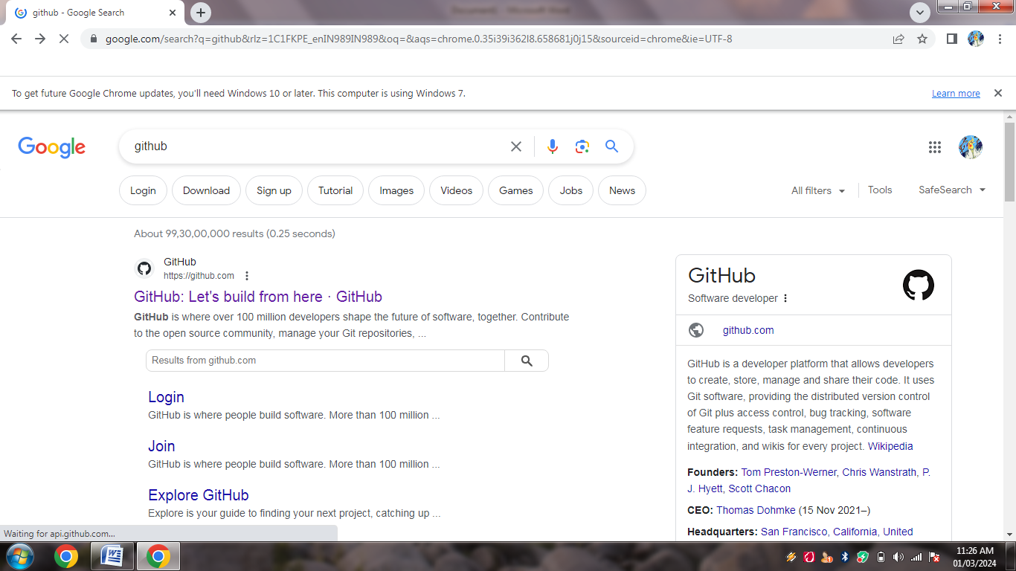

Step 2: Then open the fisrt website and enter on the sign up option to create account in github

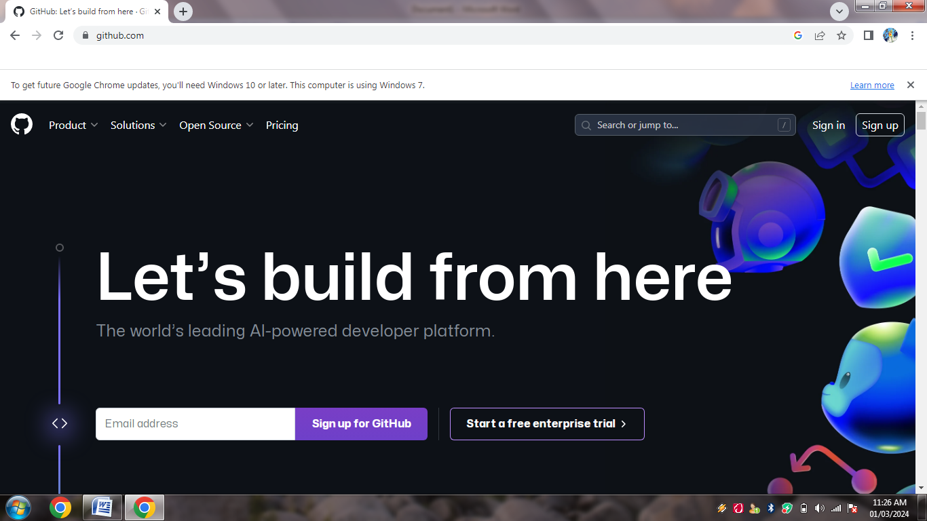

Step 3: enter the details for creating an account

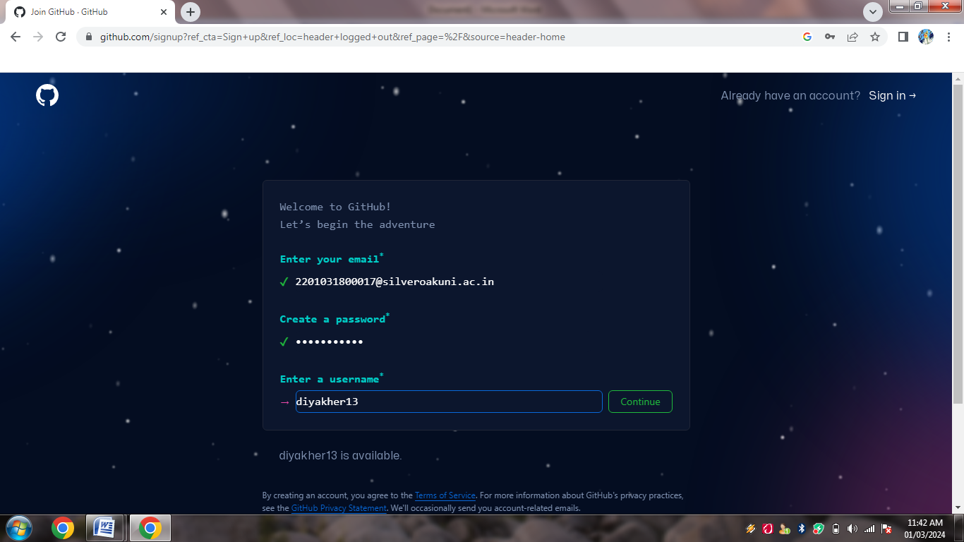

Step 4: sign up into the github to creat a repository.



Step 5:and then after selcting new repository need to creat repositor

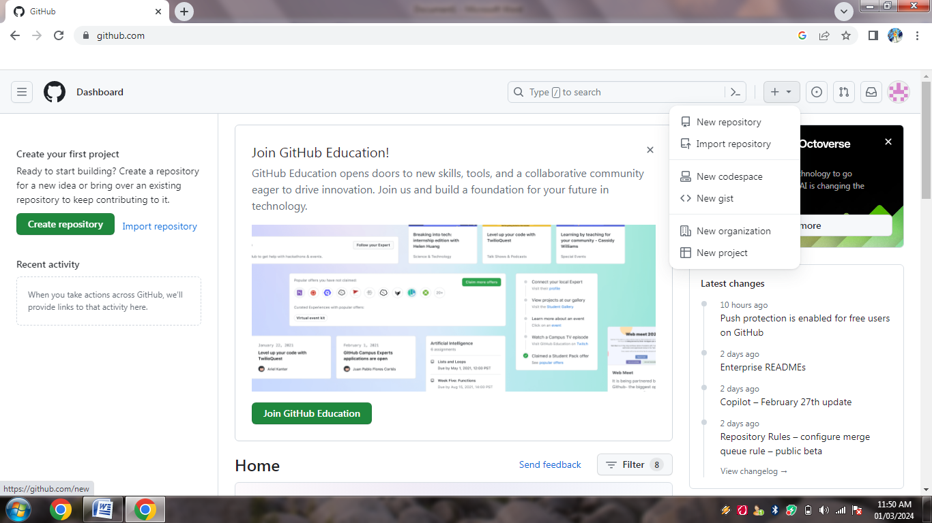

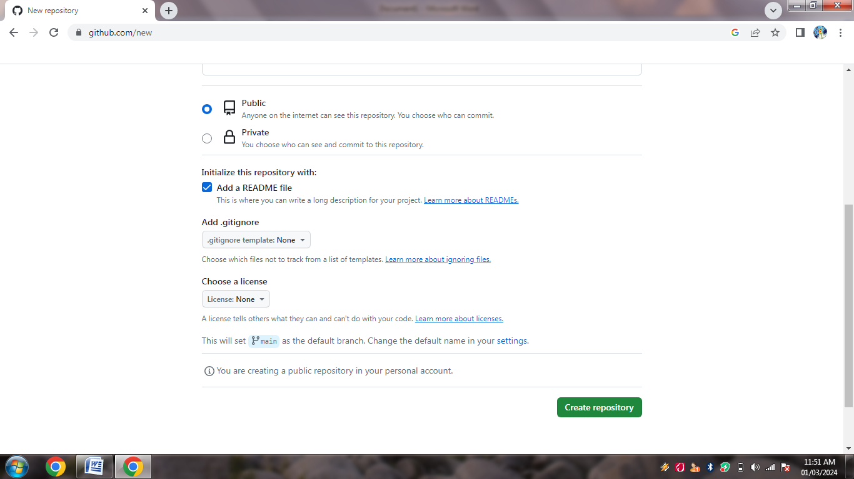

Step 6:

Step 7:enter the enrollment no.

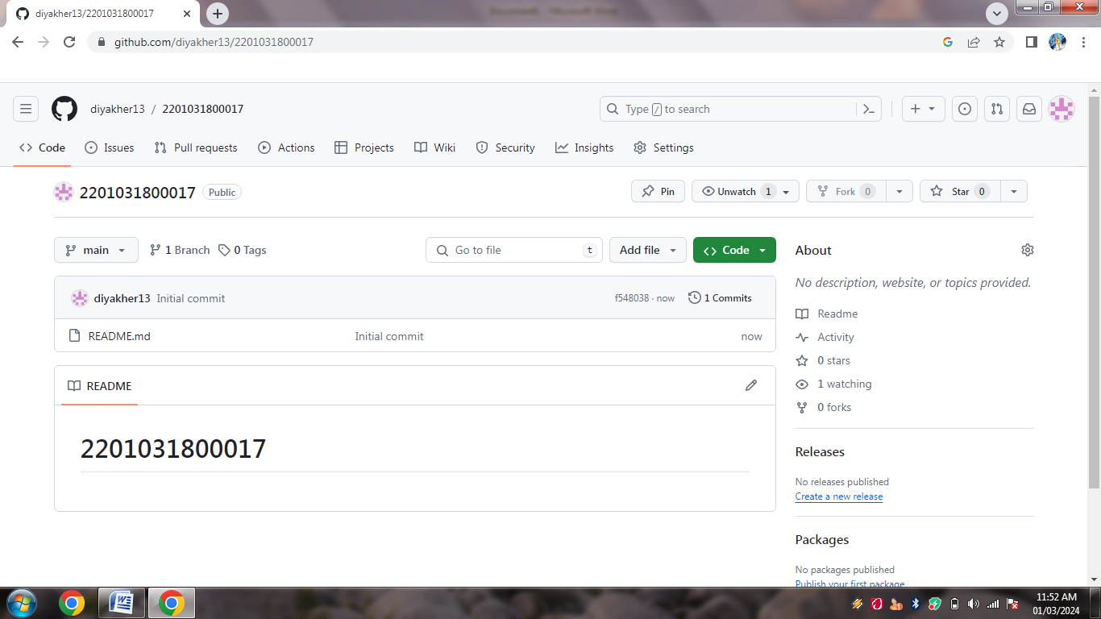

Step 8: create assignment 1.